**Project Proposal**

|  |  |
| --- | --- |
| **Semester** | W2023, SEM 2 |
| **Course Code** | AML-2404 |
| **Section** | Section 1 |
| **Group Name** | Group 6 |
| **Student names/Student IDs** | Swapnilkumar Prajapati C0886908  Sairam kilari C0884870  Jay Siddhpura C0882347  Nikhil Sharma C0867232  Amarnadh Movva C0884107 |
| **Reporting Week** | Week - 2 |
| **Team Lead for the reporting week** | Swapnilkumar Prajapati |

**Title: Identifying Contrails to Reduce Global Warming using Machine Learning**

**1. Abstract**:

This proposal aims to tackle the pressing issue of contrails and their significant contribution to global warming. Our objective is to develop an advanced machine learning system capable of accurately identifying contrails and implementing targeted mitigation strategies. By leveraging cutting-edge image processing techniques and comprehensive data analysis, our interdisciplinary team seeks to make a substantial impact on climate change mitigation efforts.

The project will span a specific duration, during which we will collect a comprehensive dataset encompassing contrail images, flight data, and pertinent atmospheric conditions. Through the utilization of this dataset, we will develop sophisticated machine learning algorithms designed to process and analyze the images, effectively distinguishing contrails from other atmospheric phenomena. Additionally, we will establish collaborations with industry partners within the aviation sector to ensure the practicality and scalability of our proposed solutions.

The outcomes of this project have the potential to yield substantial benefits for both the aviation industry and the environment. By accurately identifying contrails and implementing targeted mitigation strategies, we aim to reduce contrail formation and minimize their adverse impact on global warming. This proposal recognizes the urgency and significance of addressing this issue to safeguard the environment and foster a sustainable future for generations to come.

**Roles and Duties of each member:**

Nikhil Sharma: Gathering Data and front end.

Sairam Kilari: Data cleaning and enrichment.

Jay Siddhpura: Data Visualization.

Swapnil Prajapati: Data cleaning, Machine Learning Modelling and Testing.

Amarnadh Movva: Researching, Documentation and Front end.

**2. Statement of Need**:

The issue we seek to tackle is the environmental impact of contrails, which are the visible trails formed by aircraft engine exhaust in the upper atmosphere. Contrails contribute to global warming by trapping heat, thus exacerbating climate change. Given the rapid growth of air travel and its associated emissions, it is essential to develop effective measures for mitigating contrail formation and persistence. This proposal recognizes the urgency of addressing this issue in order to safeguard the environment for present and future generations.

**3. Project Activity, Methodology, and Outcomes:**

To achieve our goals, we will undertake the following activities:

Data Collection: We will gather a comprehensive dataset comprising images of contrails, flight data, and corresponding atmospheric conditions.

Image Processing: Leveraging machine learning algorithms, we will process and analyze the collected images to accurately identify contrails amidst various atmospheric phenomena.

Algorithm Development: Advanced machine learning algorithms will be designed and implemented to classify and differentiate contrails from other visual elements.

Mitigation Strategies: Utilizing the identified contrails, we will devise targeted strategies to mitigate their formation and persistence. This may involve adjusting flight paths or engine parameters, among other measures.

Implementation and Testing: We will get our test data from the aviation sector, and we will implement and rigorously test the developed system to ensure its practical applicability.

Timeline: We will present a detailed timeline of activities, highlighting key milestones and deliverables throughout the project's duration.

**Development Flowchart:**

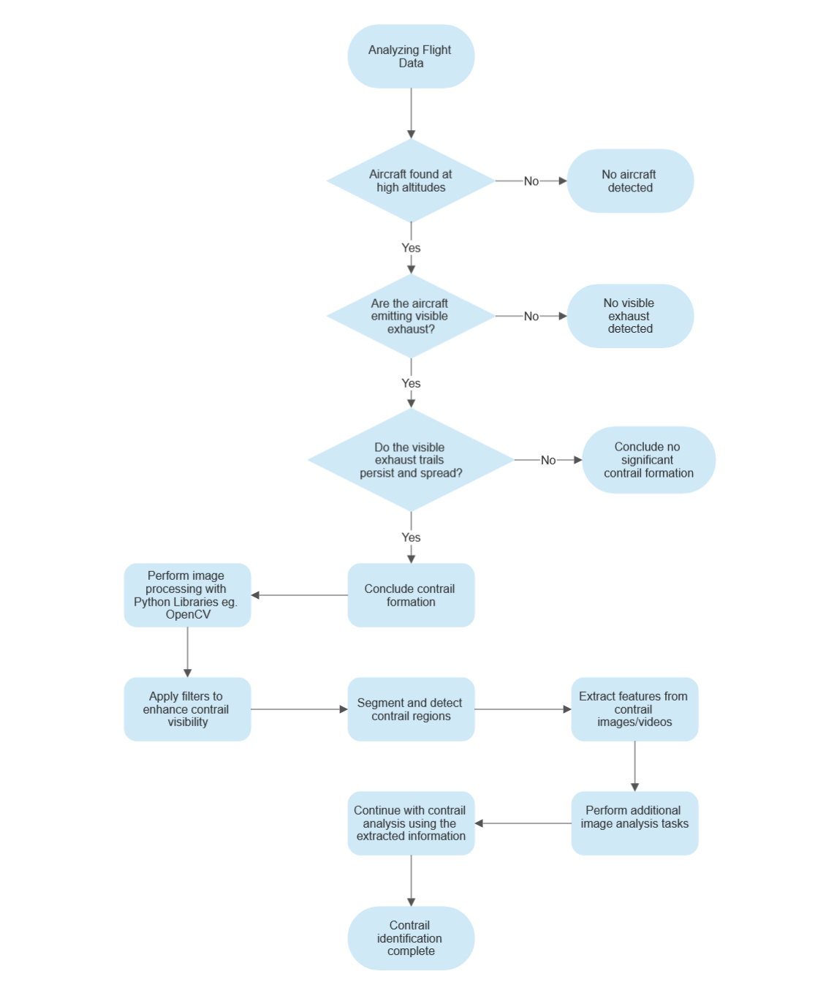

**Our expected outcomes encompass:**

**Accurate Contrail Identification**: The machine learning system will excel in identifying contrails accurately, effectively distinguishing them from other atmospheric features.

**Quantitative Analysis**: The system will provide quantitative data on contrail formation patterns, aiding in a better understanding of their impact on global warming and facilitating predictive modelling.

**Targeted Mitigation Strategies:** Real-time identification of contrails will enable the development of precise and effective mitigation strategies, ultimately reducing the overall climate impact of air travel.

**Industry Collaboration**: By involving aviation industry partners in the implementation and testing phase, we will ensure the system's practicality, scalability, and alignment with real-world requirements.

**Timeline:**

**Week 1 & 2**: Searching and Finalization of the project proposal.

**Week 3 & 4**: Data gathering phase, we will be extracting the data from different flight sources such as aviation industry data and satellite data.

**Week 5&6**: Data exploration phase, we will restructure the huge, extracted data into a readable format and performing Data transformation, Data analysis and Data visualization.

**Week 7&8**: Machine learning and Optimization, we will build robust machine learning models and apply them to the data obtained and fulfil the project objective.

**Week 9&10:** Building the Front-end. We will create an interactive user interface which will help provide ease of use and better readable outcomes.

**Week 11&12**: Conclusion and Evaluation Phase, Finally, we will Evaluate our project on Real life scenarios and generate a comprehensive report on it.

**4. Evaluation**:

To assess the project's success, we will employ the following evaluation methodology:

**Comparative Analysis**: We will compare the machine learning system's contrail identification accuracy against the expertise of human experts engaged in manual identification.

**Quantitative Metrics**: Metrics such as contrail coverage, persistence, and altitude distribution will be quantitatively measured and analyzed to evaluate the system's performance.

**Validation with Flight Data**: The system's predictions will be validated against actual flight data, ensuring its reliability and effectiveness in real-world scenarios.

By employing rigorous evaluation methodologies, we will ascertain the reliability and effectiveness of the developed machine learning system in identifying contrails and implementing targeted mitigation strategies. Through this project, we aim to contribute significantly to the reduction of global warming associated with aviation emissions.

**References:**

* Waliullah, M., Alsulaiman, M., & Lefier, Y. (2020). Automated Detection and Classification of Pistachio Nuts Using Machine Learning. Aerospace, 7(9), 121. Retrieved from <https://www.mdpi.com/2226-4310/7/9/121>
* Kaggle. (n.d.). Google Research - Identify Contrails, Reduce Global Warming. <https://www.kaggle.com/competitions/google-research-identify-contrails-reduce-global-warming/overview>
* GOES-R Program. GOES-16 Multispectral Images. <https://www.goes-r.gov/multimedia/dataAndImageryImagesGoes-16.html>